Temperature Alarm System User Manual

Sirui Xing

University of Houston

4800 Calhoun Rd, Houston, TX. 77004

1. System Overview

The temperature alarm system is able to measure the environmental temperature, and generate an alarm when the detected temperature exceeds a pre-set value. Along with the alarm, a pre-recorded piece of audio is played. User has the flexibility to pre-load any audio file from a headphone line by connecting to the Mic-in jack on the board. User can reset the alarm by pressing a stop button.

The system is implemented on the Arrow SoCkit board. The figure of Arrow board is shown below.

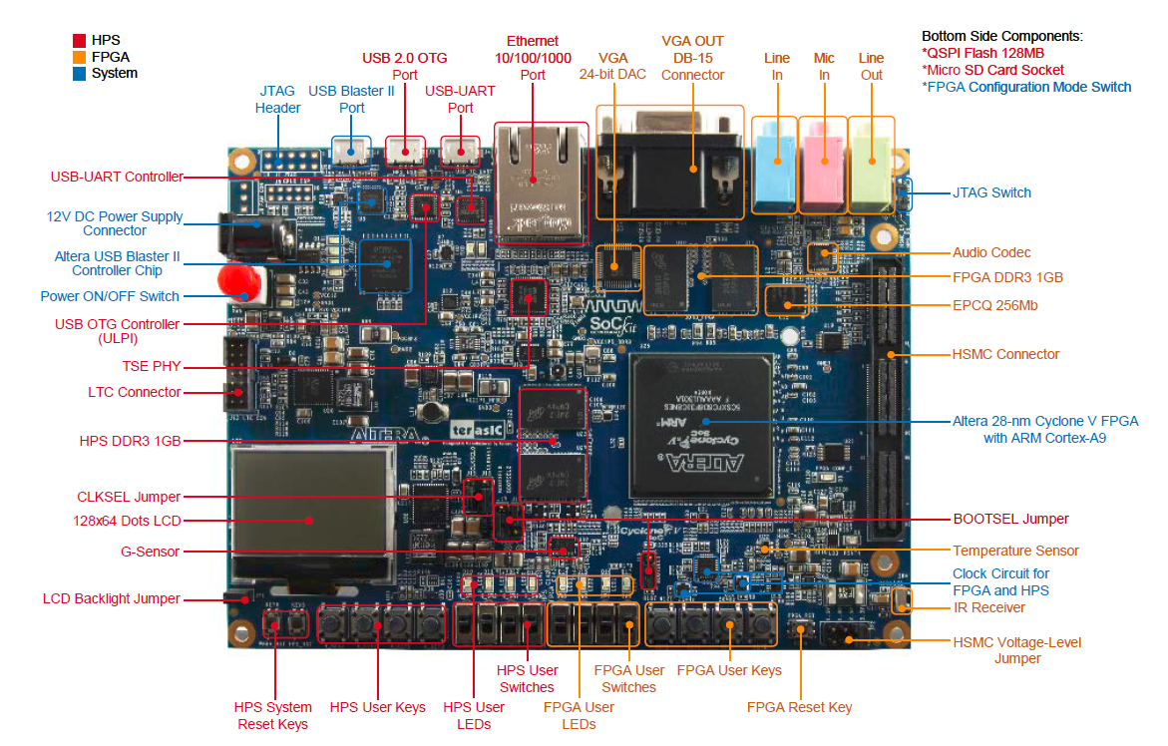

Arrow SoCkit board is designed by terasic company in Taiwan, Republic of China. It utilizes Altera Cyclone V series FPGA along with abundant peripherals. In our system, we use audio Codec, DDR3 memory, Keys, Buttons, LEDs, on chip temperature sensor.

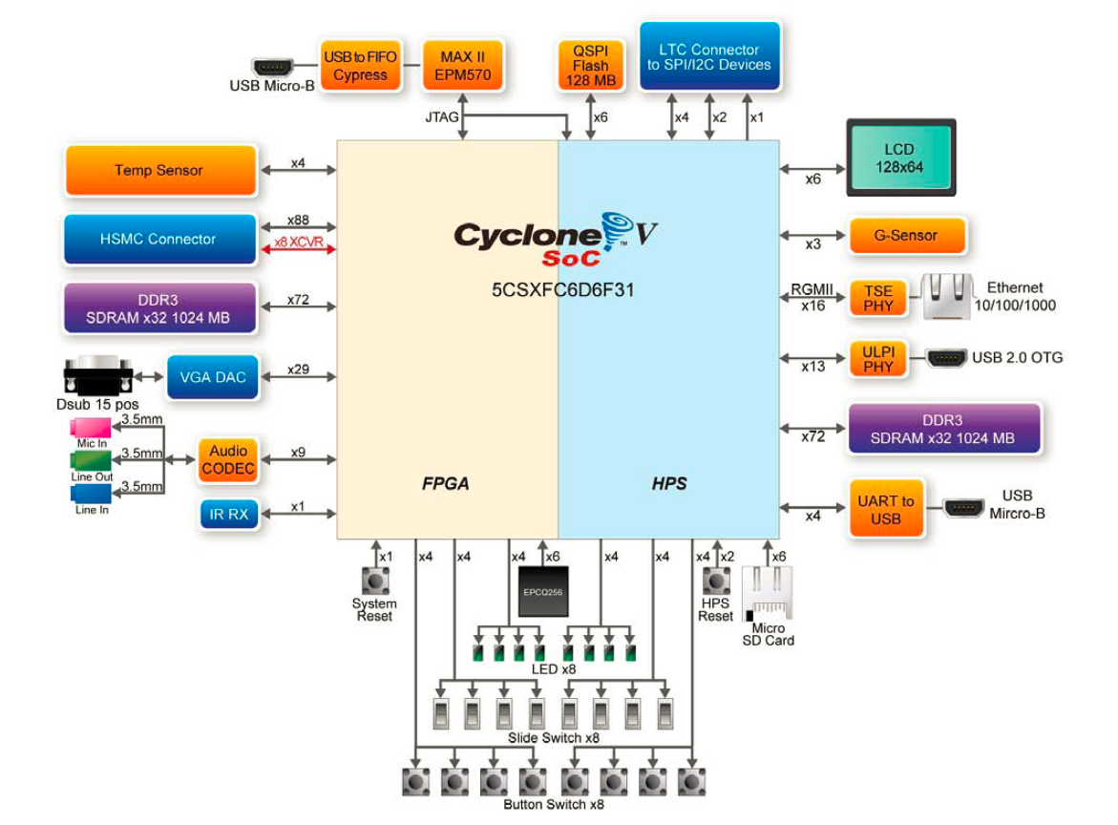

1. Hardware Design

The architecture of the temperature alarm system shows as below. All the functional components except clocks are inter-connected to the Avalon Memory Mapped Bus. NIOSII is a microprocessor for instruction execution, data store, and data fetch. Timer is set to generate an interrupt every one second. PIO are connected to external LED, switch, and button for user interface. SPI controller is to operate external temperature sensor. I2C controller is to interact with external audio CODEC. DDR3 controller is to operate external DDR3 SDRAM. JTAG Uart is for debug purpose, and is connected to a PC.

The hardware is generated from Qsys. The Qsys diagram should looks as below.

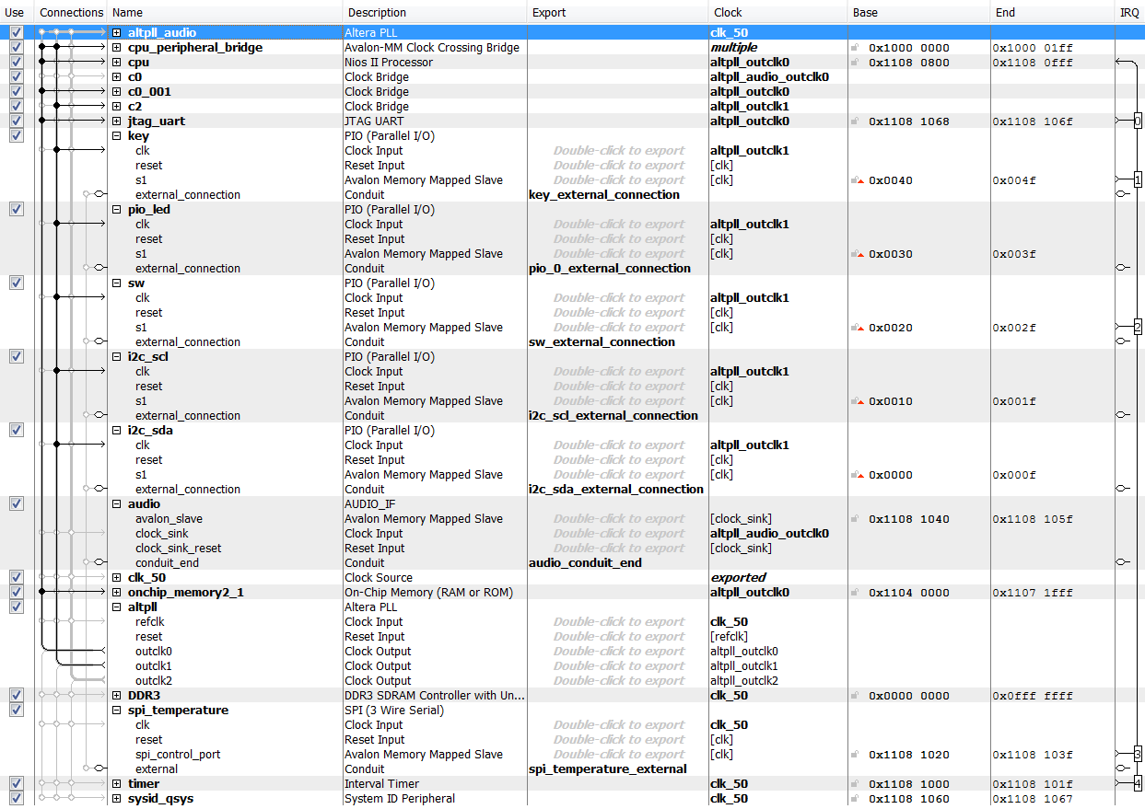

1. Software Design

Right adjacent to the hardware is some hardware API that Altera provides. A hardware abstraction layer (HAL) is also provided to facilitate application programming. The top level is user applications.

The figure below shows the software flow. The program starts by initialize all components of hardware. Afterwards, it goes into an infinite loop. Inside the loop, the main program complete temperature acquiring, audio recording, audio replaying, and change the system status. Two interrupt service functions are for button press capture and global time counter respectively.



The user interface is composed of buttons, switches, and LEDs. The function of the KEY3 is to pre-record a piece of audio file. LED3 will be on while recording. SW1, SW2 and SW3 are for sampling frequency selection. SW0 is to select the audio input method. To finish recording, press KEY3 again. Now the system continuous monitors the environment temperature. When it reaches above a certain preset value, the system will generate an alarm by playing the pre-recorded audio file.

\* KEY3: Record Start/Stop (Auto Stop when buffer is full)

\* KEY2: Stop Alarm

\* LED3: light when recording

\* LED2: light when alarm is on

\* SW0: Audio Source Selection: DOWN-->MIC, UP-->LINE-IN

\* SW3/SW2/SW1: Sample Rate Control:

\* DOWN/DOWN/DOWN-->96K

\* DOWN/DOWN/UP->48K,

\* DOWN/UP/DOWN->44.1K,

\* DOWN/UP/UP->32K,

\* UP/DOWN/DOWN->8K